Practice Test

1. Graphical user interface, text, application

   Description automatically generated

1. Graphical user interface, text

   Description automatically generated

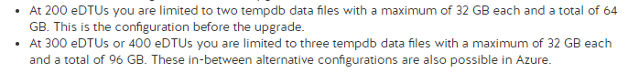

1. A screenshot of a computer

   Description automatically generated

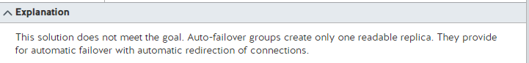

1. Graphical user interface, text, application

   Description automatically generated

1. Graphical user interface, text, application, email

   Description automatically generated



